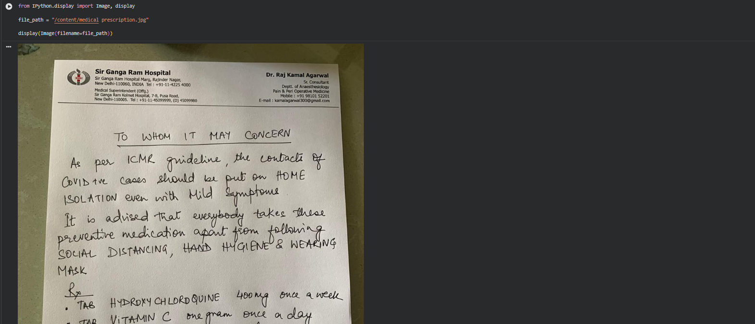
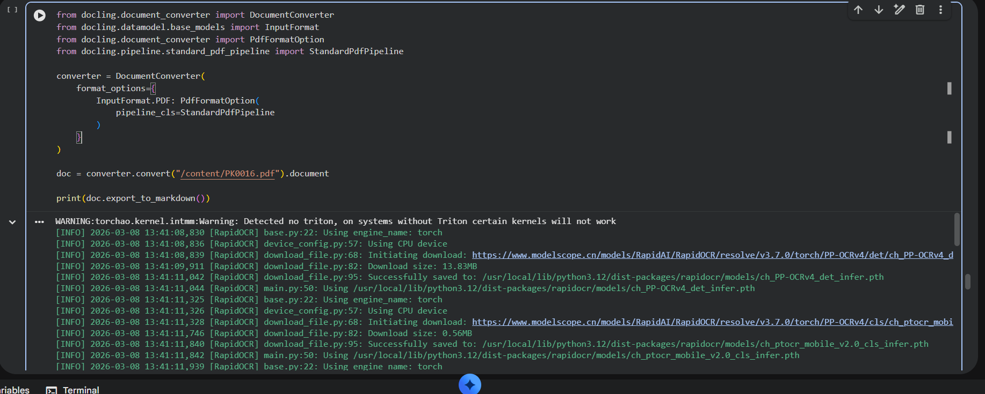
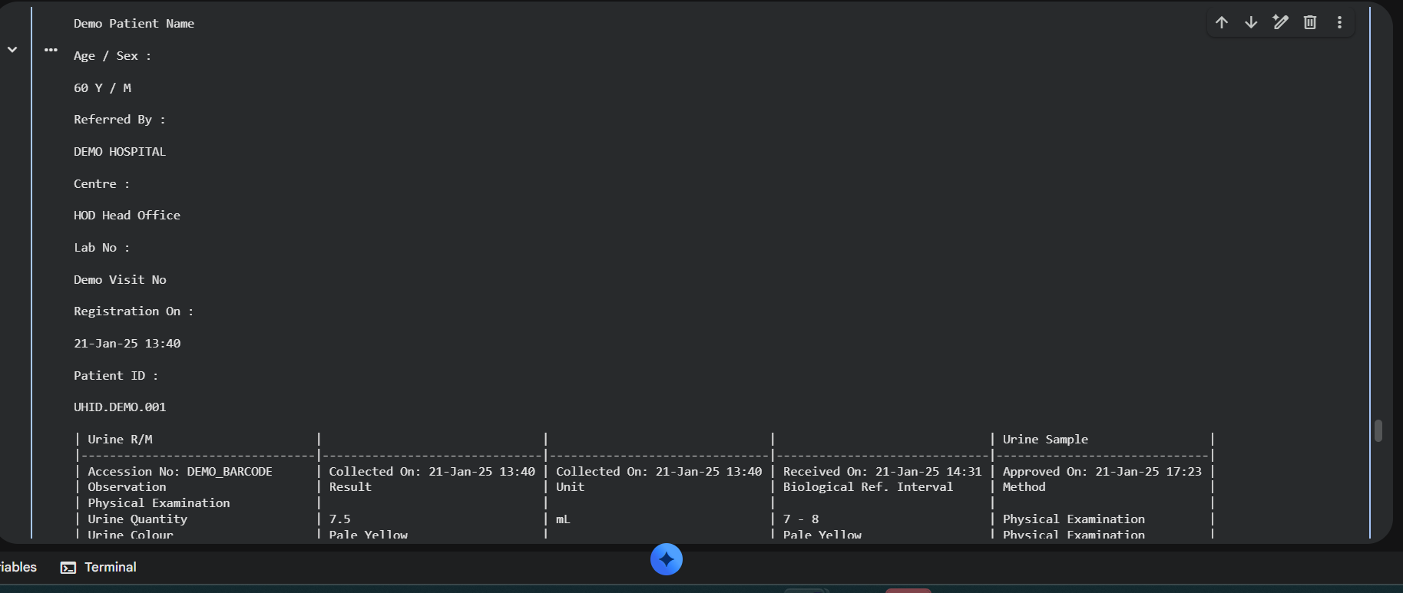
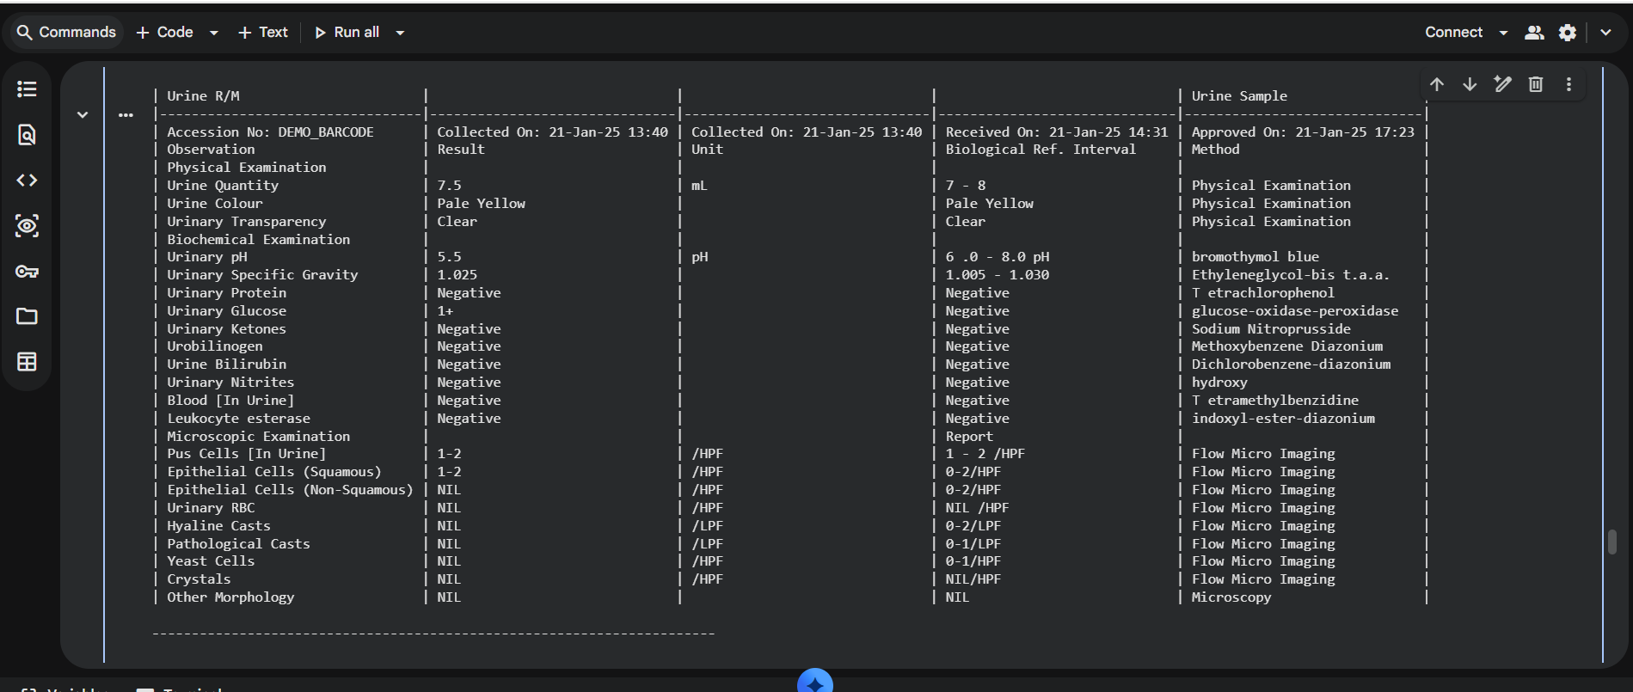
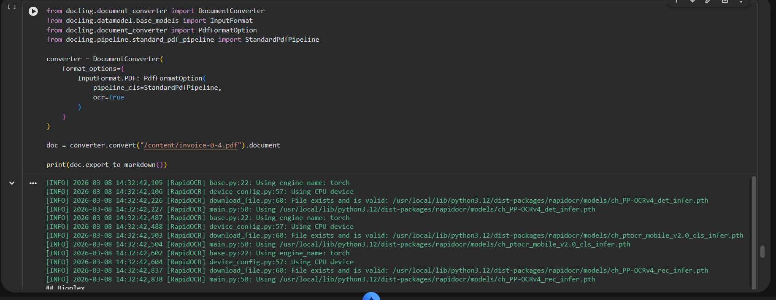
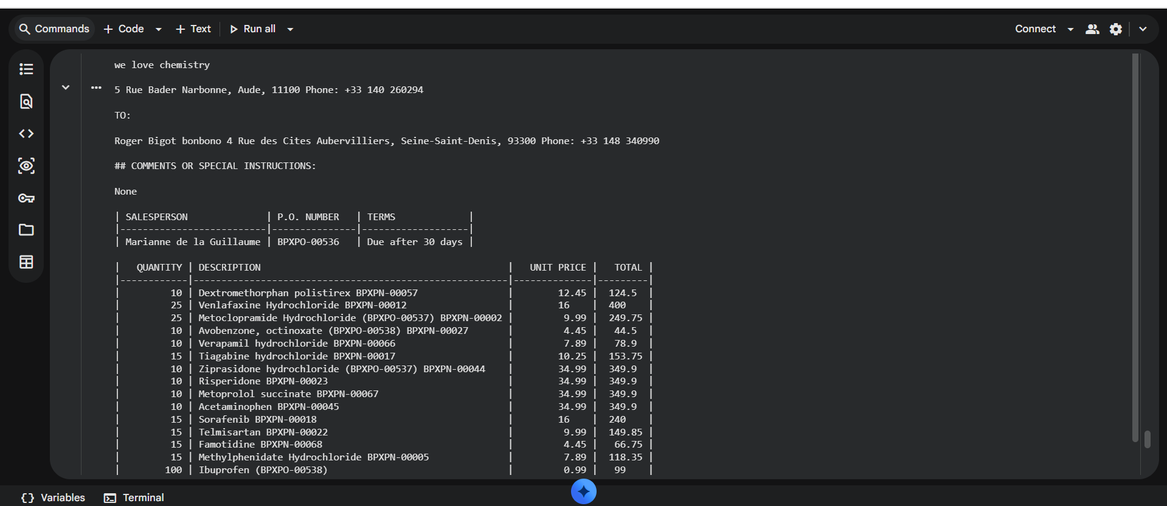

import os
import requests
from docling.document_converter import DocumentConverter
from docling.datamodel.pipeline_options import PdfPipelineOptions
from docling.datamodel.base_models import InputFormat
from docling.document_converter import PdfFormatOption
from pymilvus import MilvusClient

# --- Environment variables for gRPC and threading ---
os.environ["GRPC_ENABLE_FORK_SUPPORT"] = "0"
os.environ["GRPC_VERBOSITY"] = "ERROR"
os.environ["OMP_NUM_THREADS"] = "1"
os.environ["GRPC_ARG_KEEPALIVE_TIME_MS"] = "60000"
os.environ["GRPC_ARG_KEEPALIVE_TIMEOUT_MS"] = "20000"

# --- NVIDIA embedding API config ---
NVIDIA_API_KEY = "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"
EMBED_URL = "https://integrate.api.nvidia.com/v1/embeddings"
EMBED_MODEL = "nvidia/nv-embed-v1"

HEADERS = {
"Authorization": f"Bearer {NVIDIA_API_KEY}",
"Content-Type": "application/json"
}

# --- Milvus Lite client ---
client = MilvusClient(uri="milvus_demo.db")
collection_name = "docling_documents"

# --- Function to get embeddings from NVIDIA API ---
def embed_text(texts, input_type="passage"):
payload = {
"model": EMBED_MODEL,
"input": texts,
"input_type": input_type,
"encoding_format": "float"
}
response = requests.post(EMBED_URL, headers=HEADERS, json=payload, timeout=60)
if response.status_code != 200:
raise Exception(f"Embedding API error {response.status_code}: {response.text}")
return [item["embedding"] for item in response.json()["data"]]

# --- Load and parse PDF using Docling ---
print("\nLoading document with Docling...\n")

pipeline_options = PdfPipelineOptions()
pipeline_options.do_ocr = False
pipeline_options.do_table_structure = True

converter = DocumentConverter(
format_options={InputFormat.PDF: PdfFormatOption(pipeline_options=pipeline_options)}
)

doc = converter.convert("/mnt/c/Users/pabbidi/Downloads/PK0016.pdf").document
text = doc.export_to_markdown()

print("\n----- DOCLING OUTPUT -----\n")
print(text[:2000], "..." if len(text) > 2000 else "")

# --- Chunking: 100 words per chunk ---

chunk_size = 100
overlap = 20
chunks = []

for block in [c.strip() for c in text.split("\n\n") if c.strip()]:
words = block.split()
start = 0
while start < len(words):
end = start + chunk_size
chunk = " ".join(words[start:end])
if chunk:
chunks.append(chunk)
start += (chunk_size - overlap)

# --- Generate embeddings ---
print("Generating embeddings for chunks...")
vectors = embed_text(chunks, input_type="passage")
dimension = len(vectors[0])
print("Embedding dimension:", dimension)

# --- Create collection in Milvus Lite ---
if collection_name in client.list_collections():
client.drop_collection(collection_name)

client.create_collection(collection_name=collection_name, dimension=dimension)

# --- Insert chunks and embeddings into Milvus ---
data = [{"id": i, "vector": vectors[i], "text": chunk} for i, chunk in enumerate(chunks)]
client.insert(collection_name, data)
print(f"\n{len(data)} chunks inserted into Milvus Lite")

